**School Management System**

Diya Dangol, Prashant Bista, Utsav Thapa,

Angel Bista, and Sonal Yadav

BSc. (Hons.) Computing, Softwarica College of IT and E-commerce, Coventry University

ST4009CEM: Computing Activity Led Learning Project 2

Ujjwal Humagain

May 6, 2022

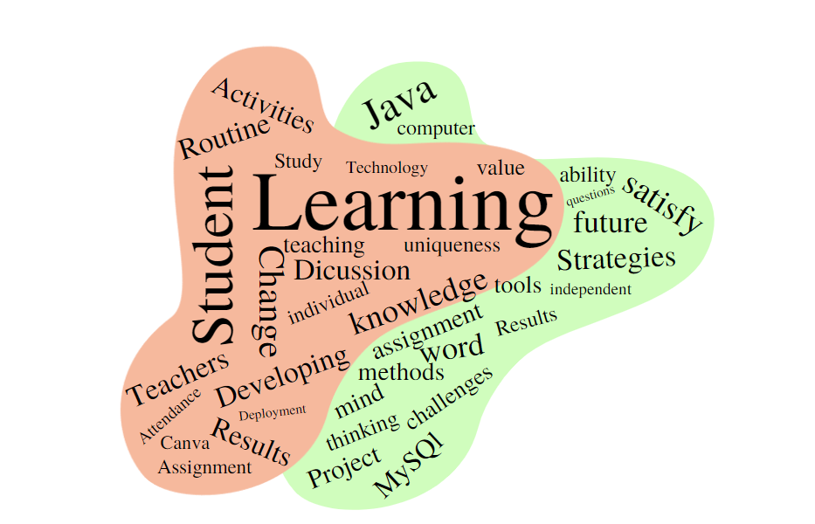

**Table of Contents**

Student Management System 5

Aim 6

Objectives 6

1. Personal Objectives 6

2. Academic Objectives 6

3. Technical Objectives 6

Problem Statement 7

Data And Research 8

Features and Functionalities 9

1. Functional Requirements 9

2.Non-functional requirements 9

Methodology 10

Agile Scrum 10

Scrum 11

Project Strategies 12

Risk Mitigation Strategies 13

Tools and technologies 14

Scope 14

Gantt Chart 15

Project Plan and Deliverables 15

SWOT Analysis 16

Conclusion 16

References 17

**Table of Figures**

Figure 1 Problem Statement 7

Figure 2 Agile Scrum 10

Figure 3 Scrum 11

Figure 4 Hardware Failure 13

Figure 5 Software Failure 13

Figure 6 Data Privacy 13

Figure 7 Tools and Technology 14

Figure 8 Scope 14

Figure 9 Gantt Chart 15

Figure 10 Milestones 15

Figure 11 SWOT Analysis 16

# Student Management System

Education of the day plays a major role in the development of all nations. Many educational institutions are trying to improve the quality of their education. One aspect of this improvement is the management of school resources. An education management system operated by an individual or institution engaged in providing services to students, teachers, parents, etc. is an intermediary that performs one or more of the following functions: Student Admission, Staff Registration, Student list, Staff list, Student attendance, Staff attendance, Student routines, Results management, Salaries, and accounts. The school management system "SMS" is a service that provides all services to make your life easier and faster by ensuring the performance of educational institutions. Simple user management system, simple admission process, simple attendance system. EMS is a system that gives an overview of the overall structure of the education system institution ("School Management System Software - Student Information System - MySchool", 2022). It is a management information system that helps manage various processes of educational institutions such as general management, human resources management, scholars, and student management. Account etc. Information is created using the latest technology to help you make decisions. It's much faster, more effective, and easier than ever before. It also helps improve the overall quality of education at the institution ("Best School Management Software in 2022 – Reviews Good Firms", 2022).

# 

# Aim

Improve school workflows and automate repetitive tasks.

# Objectives

## 1. Personal Objectives

a. Assists in the improvement of research quality.

b. Contributes to the expansion of individual and team effective communication.

c. Contributes to the establishment of group work.

## 2. Academic Objectives

a. Be able to provide written documentation as well as a functional system

b. Obtain project credits and pass the module with adequate marks.

## 3. Technical Objectives

a. Management of records of the students and teachers.

b. All data is centralized and accessible.

c. Organization of the timetables, routines, and attendances of students.

d. Management of course and subject according to the grade.

e. Reducing the communication gap between teachers and students.

f. Analysis of the student performance and progress.

# Problem Statement

There was a lot of data and information on students in the past, but there was no systematic data arrangement in student management. Another issue that may arise is the difficulty in searching for and updating student information and class arrangements. Teachers, like administrators, have various challenges in developing student performance, such as student discipline, results, attendance, and so on, because there is no systematic record ("SCHOOL MANAGEMENT SYSTEM", 2022).

Figure 1

*Problem Statement*

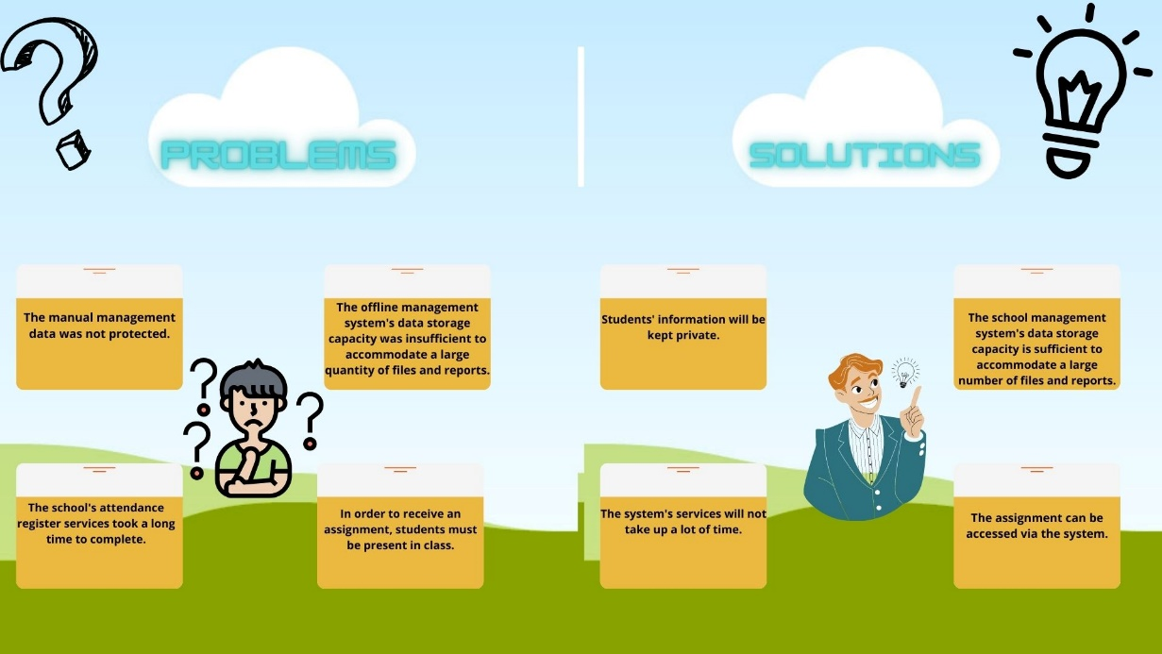**Figure 1**

However, there is now a system in place to manage data and information. Admin does not need to find any paper or files to look for student information, but can simply click and receive it. Students are not required to attend school to get test results. Students will be able to view the results via the app.

# Data And Research

A school management system is PCR Educator School Management System. It is a one-stop-shop for linking your whole school, from admission through registration. PCR Educator's School Management System demo revealed various flaws. The drawbacks were that the routine was not shown on time, and students may confront a host of troubles as a result of inadequate routine management ("Research", 2022). As a result, we have put in place a complete management system that ensures routines are kept up to date and published on time. Students will know where they should go and when they should arrive as a result of this. This also helps individual teachers choose the best classroom and teaching time ("PCR", 2022).

School Works Pro is a web-based school management system. It's been a year since I've used this website. It's also a piece of school administration software. The undesirable features of this website, are that if you do not pay your payments by the deadline, your modules will be disabled. It has a direct impact on the student's ability to learn. Students are unable to give quizzes or view the contents of the modules if the modules are banned. Student module will not be able if there did not respond to the tickets (Technology, 2022).

PCR Educator School Management and School Works Pro both have many problems like routine not being up to date. But, in this system, there will not be any problems with routine and module blocks. There will be access to all the students who have paid the fee or not.

# Features and Functionalities

## 1. Functional Requirements

1. All students at a certain school who are reading must have access to the system.
2. Admin should be able to offer routine information.
3. The attendance must be visible to the students.
4. Teachers must be able to update the module's content.
5. It is not permitted to use the same ID for two or more students.
6. If the class is conducted, teachers must take daily attendance.
7. If fees are not paid on time, the module will be disabled ("Functional vs Non-functional Requirements: Examples and Types", 2022).

## 2.Non-functional requirements

1. Efficiency: This approach allows students or professors to simplify their job. The learner may quickly search for and obtain modules using this method. In addition, the admin will have to spend less time on this. As a result, the school management system's throughput is increased.
2. Reliability: The system performs tasks with more precision, such as user registration, validation, authorization, module search, and attendance status, as well as updating the database through database and application synchronization.
3. Usability: The suggested school administration system provides a user-friendly environment for users so that instructors and students may use the system effectively for job efficiency.
4. Delivery: When developing a project, a time frame is always stated. Similarly, this system is projected to be finished in one month. This launch will be used to improve performance since it will be assessed by users, and then any issues with the system will be addressed.
5. System Implementation: Java was utilized to construct this system. Java has also been employed because it is simple to use and effective for database connectivity. MySQL has been utilized for the backend, which contains the database

# Methodology

## Agile Scrum

Figure 2

*Agile Scrum**("Agile", 2022)*

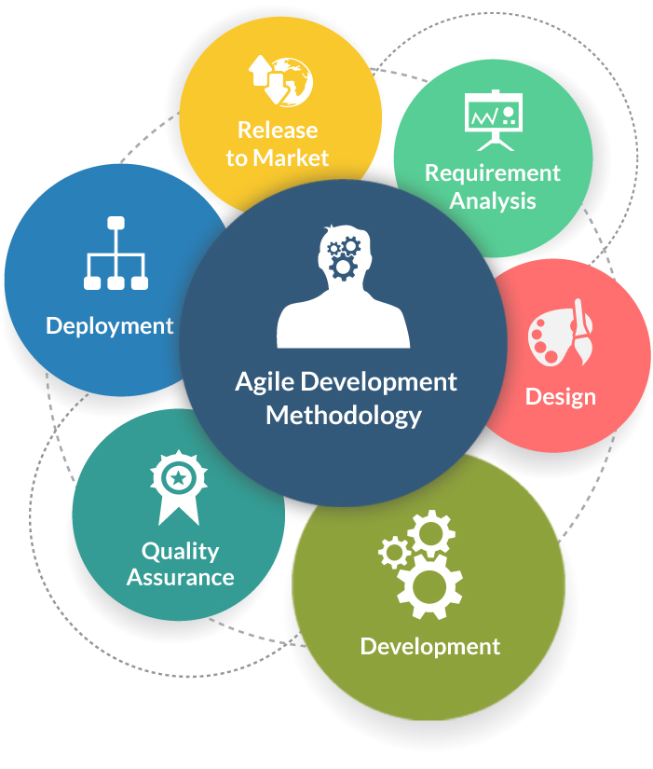

The AGILE technique was employed for this project's planning and development.

The Agile software development technique is one of the most straightforward and efficient methods for translating a vision for a business need into software solutions. Agile software development methodologies involve continuous planning, learning, improvement, team participation, evolutionary development, and early delivery. It promotes adaptable reactions to change. In agile methodology also scrum process is used for the development of the project.

## Scrum

Figure 3

*Scrum ("Scrum", 2022)*

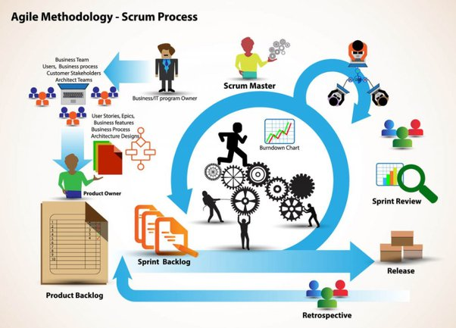

The product backlog was created first in the scrum process. Trello was used to create the product roadmap. Following the sprint meeting, the sprint backlog was created to identify the sprint's goal. After assigning tasks to members, the scrum master has daily scrum meetings for 10-15 minutes to discuss the team's progress and any difficulties that occur in the project. The backlog will be reviewed with the product owner at the sprint review. During the retrospective, the team discusses what worked well in the sprint and what requires improvement in the next sprint ("What is Agile Software Development (Agile Methodologies)?", 2022).

## Project Strategies

**1. *Define objectives early on and keep them adjustable***: To begin, establish the project's purpose, scope, and upcoming modifications so that it will be easier to adapt the approaching project's goals in time to maximize efficiency. Keep the team up to date on the project's plans and modifications. If someone is ignorant of them, inform them as soon as possible (Lucco et al., 2022).

**2.** ***Understand the project scope want to handle***: Understand the project and the tasks that must be completed. Determine the project scope, which will assist the project manager in allocating resources to the task and dividing it fairly among team members. To satisfy project goals and complete the project, conduct research on the project's needs, the product owner's needs, and the team's needs.

**3. *Interaction with the product owner and team members****:* Interaction is critical to project growth because it helps team members realize the project's requirements and the obstacles they will face while building the project. Interaction is also necessary for the product owner to appreciate the expectations and respond to changes in the project. Clients should provide clear and honest feedback, and modifications should be made in response to the input ("12 Project Management Strategies To Improve Efficiency", 2022).

4. ***Promote coordination and risk management****:* The team is the most significant aspect of the project since it necessitates the efforts and hard work of many individuals working together. Encourage members to stay focused on their tasks and avoid distractions. Perform a risk analysis before beginning the development process, as well as a mitigation procedure to lessen it. Risk analysis should be performed so that each step of the project is less startling.

## Risk Mitigation Strategies

1. ***Hardware Failure****:*

**Figure 4**

*Hardware Failure* (2022)



Hardware failure is the most serious threat to any system or project. To mitigate this risk, the project must be backed up on the cloud. The backup must be performed when each task is completed. Pay close attention to the hard maintenance regularly. Check for any unneeded programs operating on the hardware and scan for viruses regularly.

1. ***Software Failure****:*

**Figure 5**

*Software Failure*

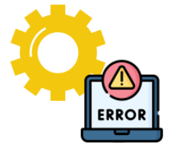Failure of software is also a significant risk in the project. The team's efforts may be considered unusable if the program fails. To avoid this danger, do not use pirated software. Do not open any strange files or emails. Most essential, retain a backup.

1. ***Data Privacy****:*

**Figure 6**

*Data Privacy*

******Data privacy should also be included since horrible things can happen if system data falls into the wrong hands. Keep the data secure and do not disclose project ideas to anybody other than the team

# Tools and technologies

Figure 7

*Tools And Technology*

**Figure 4**

# 

# Scope

Figure 8

*Scope*

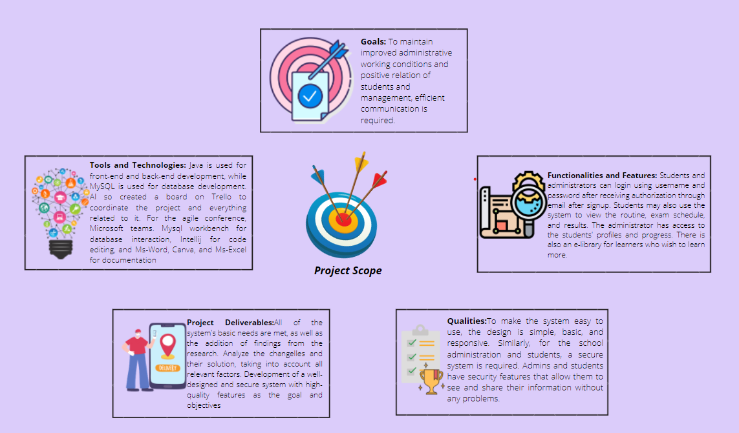**Figure 5**

# Gantt Chart

Figure 9

*Gantt Chart*

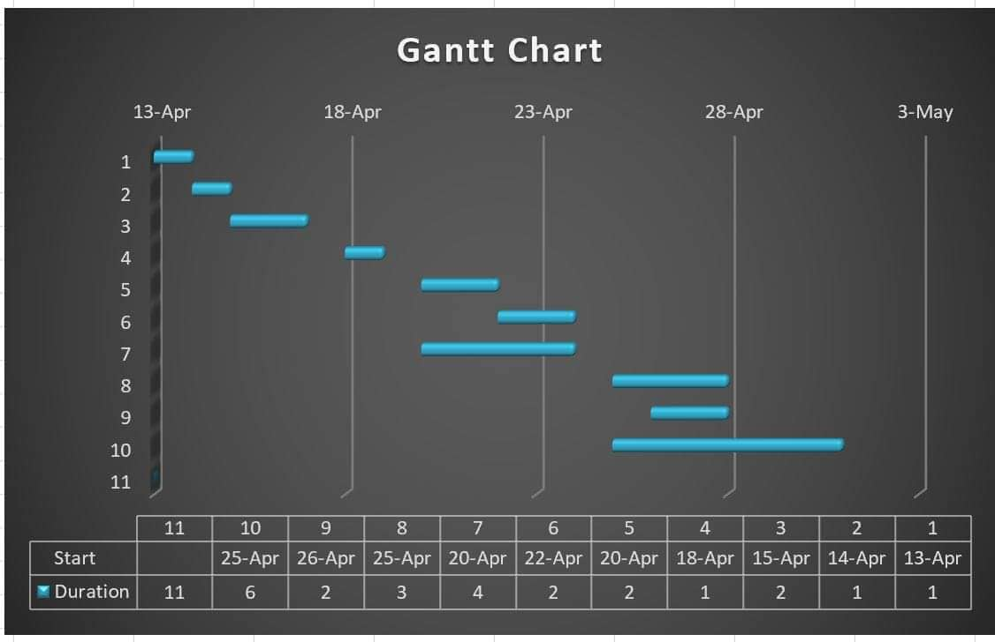Gant Chart

# Project Plan and Deliverables

**Figure 10**

*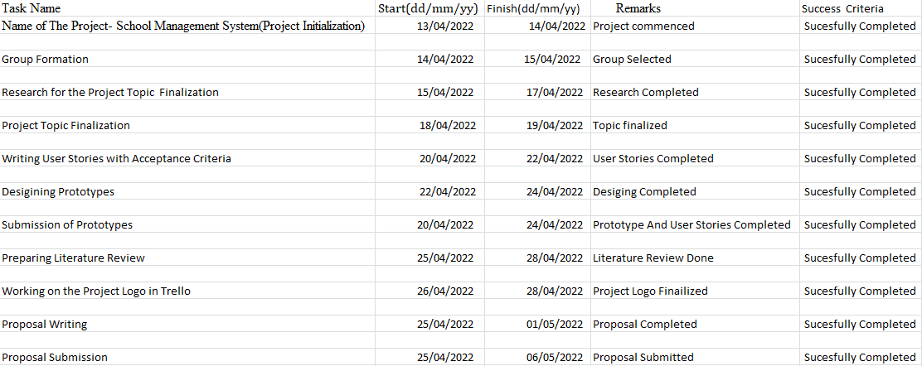Milestones*

# SWOT Analysis

Figure 11

*SWOT Analysis*

**Figure 6**

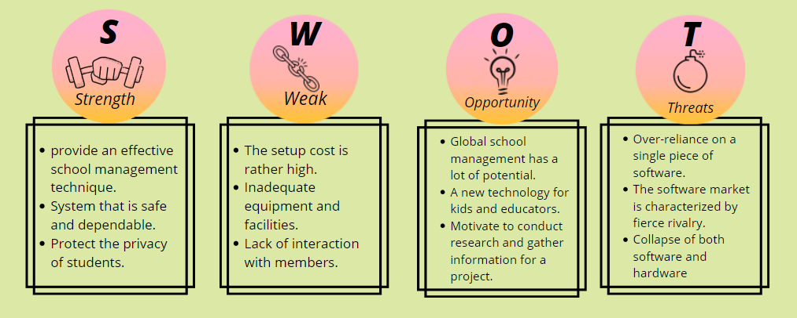

# Conclusion

This application will help the school to manage the data and information systems and students get an education through the desktop application. School Management System is not only for the school administration but it is also for the student better education and to make learning easier for students. Students do not have to face the difficulty of not having books, coming to school for results, missing the class and exams, etc.

## References

12 Project Management Strategies to Improve Efficiency. Indeed Career Guide. (2022). Retrieved 6 May 2022, from <https://www.indeed.com/career-advice/career-development/project-management-strategies>.

Best School Management Software in 2022 - Reviews |GoodFirms. Good firms. co. (2022). Retrieved 6 May 2022, from <https://www.goodfirms.co/school-management-software/>.

*Functional vs Non-functional Requirements: Examples and Types*. VironIT. (2022). Retrieved 6 May 2022, from <https://vironit.com/functional-vs-non-functional-requirements/>.

Lucco, J., Trammell, H., Jackson, T., & Weaver, J. (2022). *Develop A Project Strategy In 8 Steps*. Clear Point Strategy. Retrieved 6 May 2022, from <https://www.clearpointstrategy.com/project-strategy/>.

*School Management System Software - Student Information System - MySchool*. Trymyschool.com. (2022). Retrieved 6 May 2022, from <https://www.trymyschool.com/>.

Technology, D. (2022). *schoolworkspro*. Schoolworkspro.com. Retrieved 6 May 2022, from <https://schoolworkspro.com>.

What is Agile Software Development (Agile Methodologies)?. SearchSoftwareQuality. (2022). Retrieved 6 May 2022, from <https://www.techtarget.com/searchsoftwarequality/definition/agile-software-development>.

*SCHOOL MANAGEMENT SYSTEM*. Modish Project. (2022). Retrieved 5 May 2022, from <https://www.modishproject.com/school-management-system/>.

Agile. Tatvasoft.com. (2022). Retrieved 6 May 2022, from <https://www.tatvasoft.com/blog/wp-content/uploads/2015/12/agile_software_development_methodology.jpg>.

*PCR*. (2022). Retrieved 6 May 2022, from <https://www.publicschoolreview.com/blog/10-major-challenges-facing-public-schools>.

*Scrum*. Google.com. (2022). Retrieved 6 May 2022, from [https://www.google.com/url?sa=i&url=https%3A%2F%2Fwww.quora.com%2FWhat-are-the-hot-research-topics-based-on-Scrum-and-agile-in-design-sprint-methodology&psig=AOvVaw2Zp5WmH_5nZkJO0knDfeES&ust=1651764930242000&source=*i*mages&cd=vfe&ved=0CAwQ](https://www.google.com/url?sa=i&url=https%3A%2F%2Fwww.quora.com%2FWhat-are-the-hot-research-topics-based-on-Scrum-and-agile-in-design-sprint-methodology&psig=AOvVaw2Zp5WmH_5nZkJO0knDfeES&ust=1651764930242000&source=images&cd=vfe&ved=0CAwQ).

Static.vecteezy.com. (2022). Retrieved 6 May 2022, from <https://static.vecteezy.com/system/resources/previews/002/685/540/large_2x/computer-not-starting-gradient-linear-icon-fatal-system-error-pc-crash-and-software-failure-thin-line-color-symbols-modern-style-pictogram-isolated-outline-drawing-vector.jpg>.

*Research*. (2022). Retrieved 6 May 2022, from <https://www.researchgate.net/publication/315380267_School_Management_Information_System_An_Effective_Tool_for_Augumenting_the_School_Practices>.